Participant Consent Form

Project Title: MythBreaker, an MA project aiming to change the negative perceptions of fanfiction and fandom communities

You are being invited to take part in a research project. Before you decide to take part it is important for you to understand why the research is being done and what it will involve. Please take time to read the attached information sheet carefully and discuss it with others if you wish. Ask if anything is unclear or if you would like more information.

- I understand that I have given my consent to be interviewed about my thoughts on the misconception of fanfiction and fandom communities.
- I fully give my consent to take part.
- I understand that I have given approval for my opinions to be included in the research outputs. Anything I say may be used in academic papers relating to the project, although these quotations will be anonymous.
- I understand that I have given my consent for my likeness to be filmed and recorded and that this recording will be used for research purposes only.
- I have read the information sheet about the research project, which I have been asked to take part in and have been given a copy of this information to keep.
- What is going to happen and why it is being done has been explained to me, and I have had the opportunity to discuss the details and ask questions.
- Having given this consent I understand that I have the right to withdraw from the research programme at any time without disadvantage to myself and without having to give any reason.
- I hereby fully and freely consent to participation in the study, which has been fully explained to me.

Participant’s name  (BLOCK CAPITALS): | PETER LEE |  | 2024/11/30
Participant’s signature: | 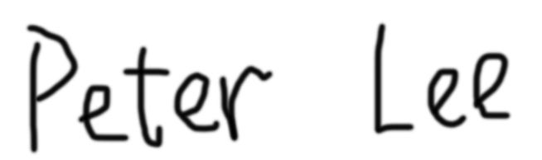 | Date:
Investigator’s name  (BLOCK CAPITALS): | XUEQING LIANG |  | 2024.11.30
Investigator’s signature: | 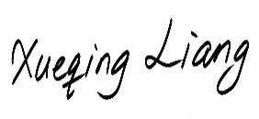 | Date:

Contact
Investigator: Xueqing Liang
Email: xq_liang2417@163.com

